 

**INGREDIENTS AND MENU ITEMS ARE SUBJECT TO CHANGE OR SUBSTITUTION WITHOUT NOTICE**

**THIS INSTITUTION IS AN EQUAL OPPORTUNITY PROVIDER**

**MEALS ARE FREE TO ALL STUDENTS**

**Offered daily**

**Whole wheat grains & variety of fruit available**

**Choice of 1% white milk or non-fat chocolate milk**

**SEPTEMBER 2024**

**FRANK WRIGHT BK MENU**

**Breakfast pizza**

**OR**

**Pumpkin bread**

**Yogurt**

**Variety of fruits**

**Breakfast pizza**

**OR**

**Hulk smoothie**

**Tiger bites crackers**

**Variety of fruits**

**Chorizo and egg**

**Burrito**

**OR**

**Concha – Yogurt**

**Variety of fruits**

**Breakfast sandwich**

**OR**

**BeneFit bar**

**Fruit juice**

**Variety of fruits**

**Bacon and egg**

**Burrito**

**OR**

**Mini waffles w/syrup**

**Variety of fruits**

**Breakfast pizza**

**OR**

**Pineapple smoothie**

**Crackers**

**Variety of fruits**

**Brekfast pizza**

**OR**

**Hulk smoothie**

**Tiger bites crackers**

**Variety of fruits**

**Chorizo and egg**

**Burrito OR**

**D’Stella assorted muffin**

**Yogurt**

**Variety of fruits**

**Breakfast sandwich**

**OR**

**Pancake on a stick**

**w/syrup**

**Variety of fruits**

**Bacon and egg**

**Burrito**

**OR**

**Apple empanada**

**Variety of fruits**

**Breakfast pizza**

**OR**

**Pineapple smoothie**

**Crackers**

**Variety of fruits**

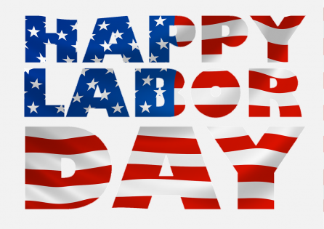

**Bacon and egg**

**Burrito**

**OR**

**Pancakes w/syrup**

**Variety of Fruits**

**Chorizo and egg**

**Burrito**

**OR**

**Pineapple smoothie**

**Variety of Fruits**

**Biscuits w/sausage**

**OR**

**Vanilla peach parfait**

**w/granola**

**Variety of Fruits**

**Breakfast pizza**

**OR**

**French toast sticks**

**W/syrup**

**Variety of Fruits**

**Breakfast pizza**

**OR**

**French toast sticks**

**W/syrup**

**Variety of fruits**

**Bacon and egg**

**Burrito**

**OR**

**Mini breakfast bits**

**Variety of fruits**

**Breakfast sandwich**

**OR**

**Bagel pizza**

**Fruit juice**

**Variety of fruits**

**Chorizo and egg**

**Burrito OR**

**Pineapple smoothie**

**Tiger bites crackers**

**Variety of fruits**

**Breakfast pizza**

**OR**

**Pancake on a stick**

**Fruit juice**

**Variety of fruits**